|  |
| --- |
| swipe to get a delete button  or just tap to cross it off |

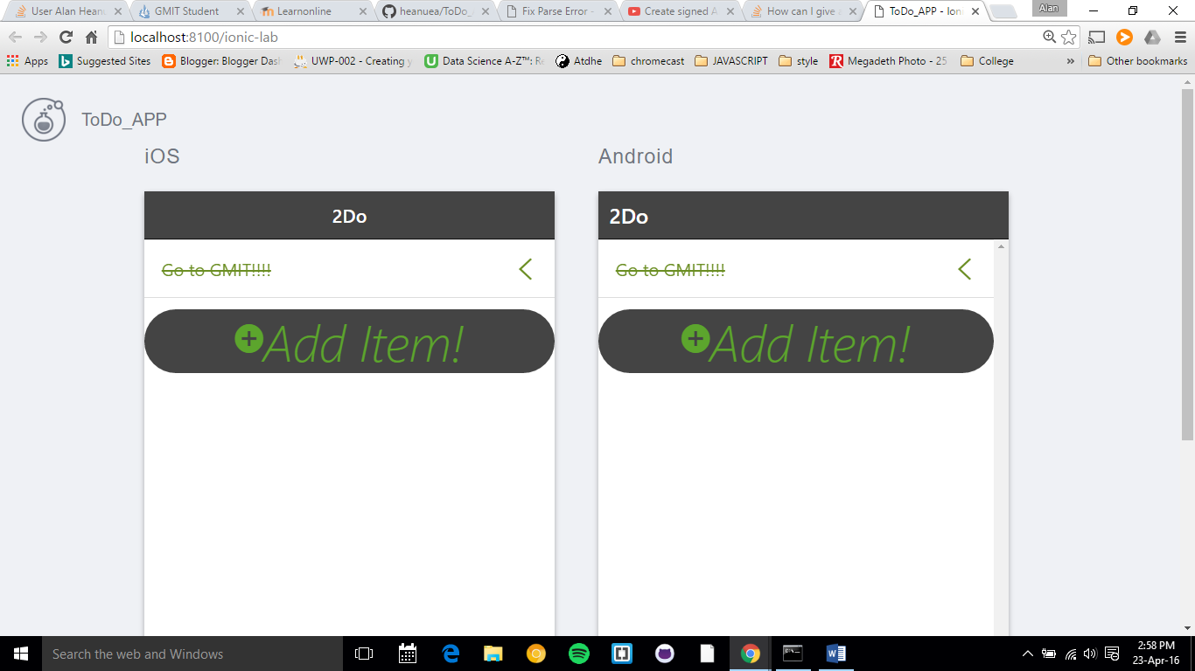

Tap to add and a pop up will appear example below

